**API VIEW AND URL'S DJANGO REST FRAMEWORK**

REF:

<https://stackoverflow.com/questions/26445450/how-to-delete-an-object-using-django-rest-framework>

<http://www.django-rest-framework.org/tutorial/3-class-based-views/>

AND EXAMPLE OF HOW TO CREATE A CLASS WHICH EXTENDS OF APIVIEW CLASS IS NEXT SHOWED:

***views.py***

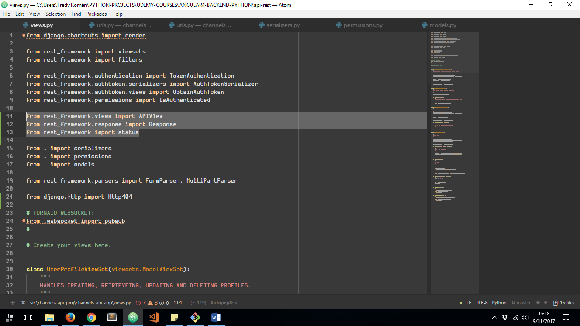

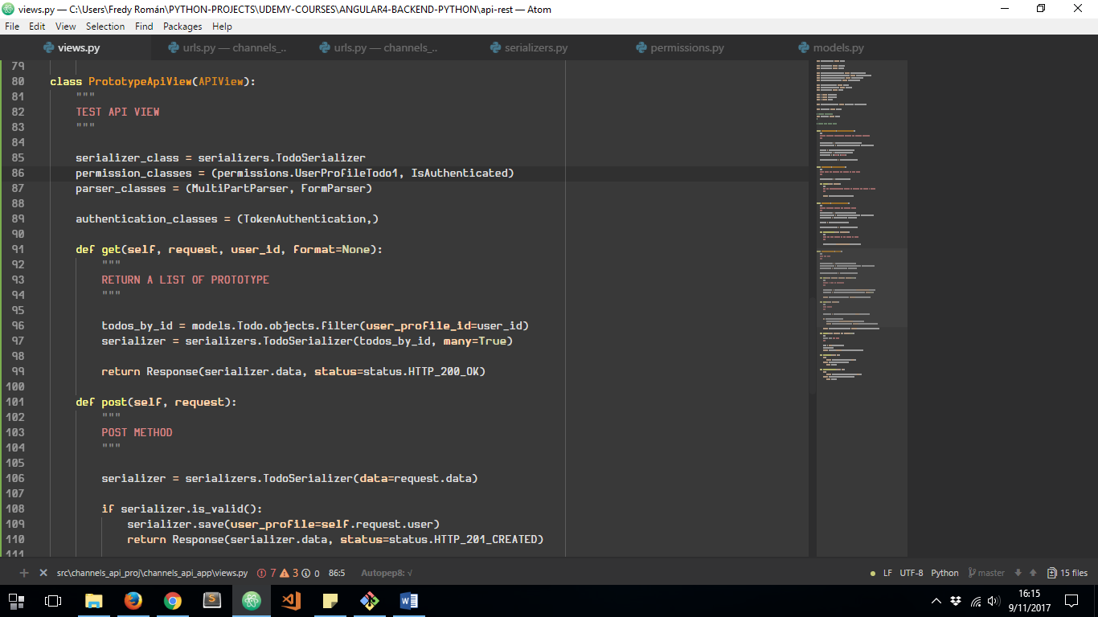

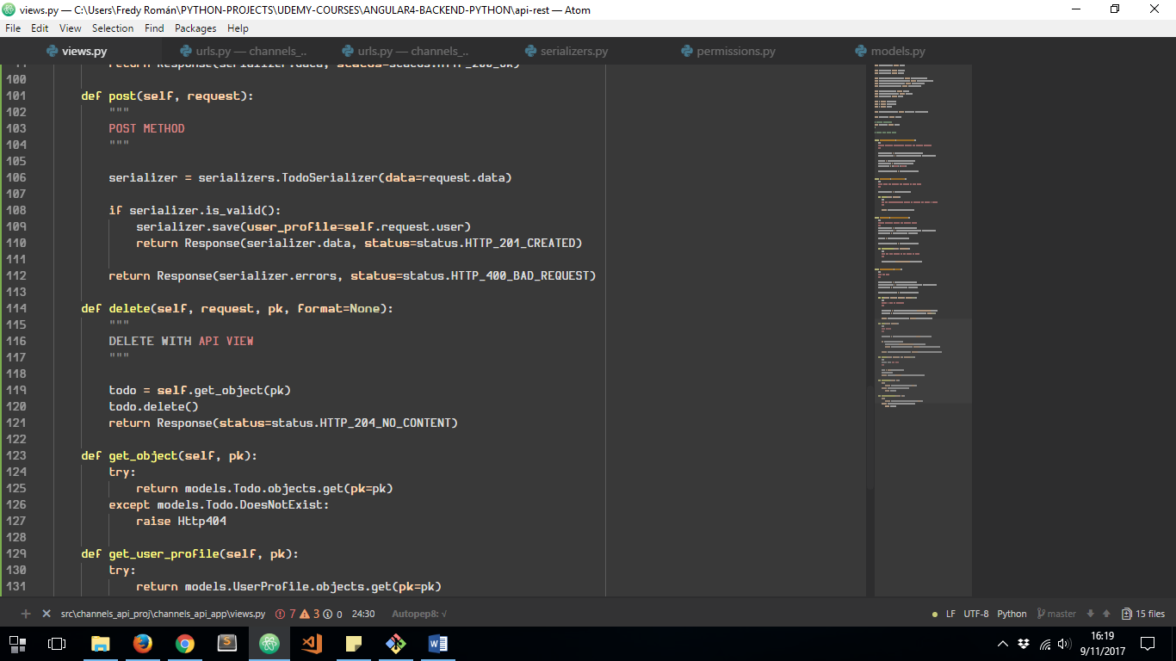

***get_object*** FUNCTION IS USED TO FIND SOME TUPLE FROM THE DATABASE ACCORDING TO A FILTER COLUMN VALUE:

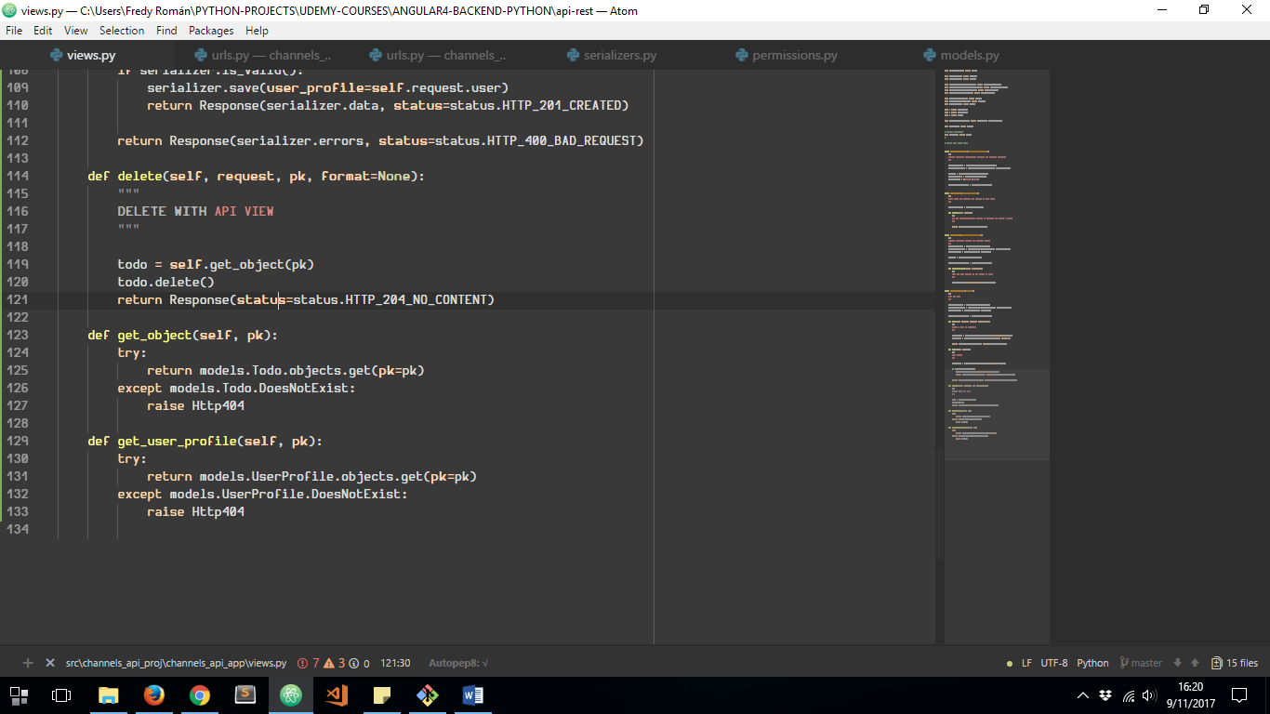

NEXT TO DO IS TO CONFIGURE THE APIVIEW URL PROPERLY:

